

**DEPARTMENT OF COMPUTER ENGINEERING**

Assignment No. 07

|  |  |
| --- | --- |
| Semester | B.E. Semester VIII – Computer Engineering |
| Subject | Data Science Honors |
| Subject Professor In-charge | Prof. Amit Alyani |
| Academic Year | 2024-25 |

|  |  |
| --- | --- |
| Student Name | Deep Salunkhe |
| Roll Number | 21102A0014 |

**Title:** Scrape customer reviews from Google & perform sentiment analysis (tweet API have been stopped)

# Implementation:

Scraping : Using standard js in console

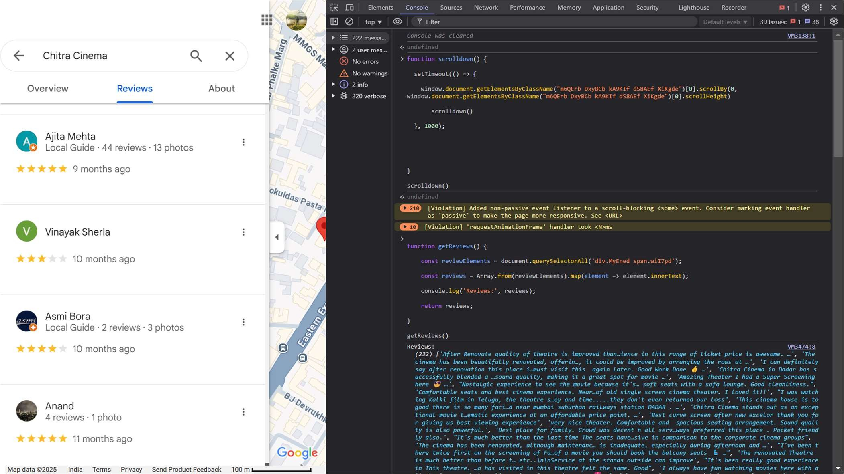

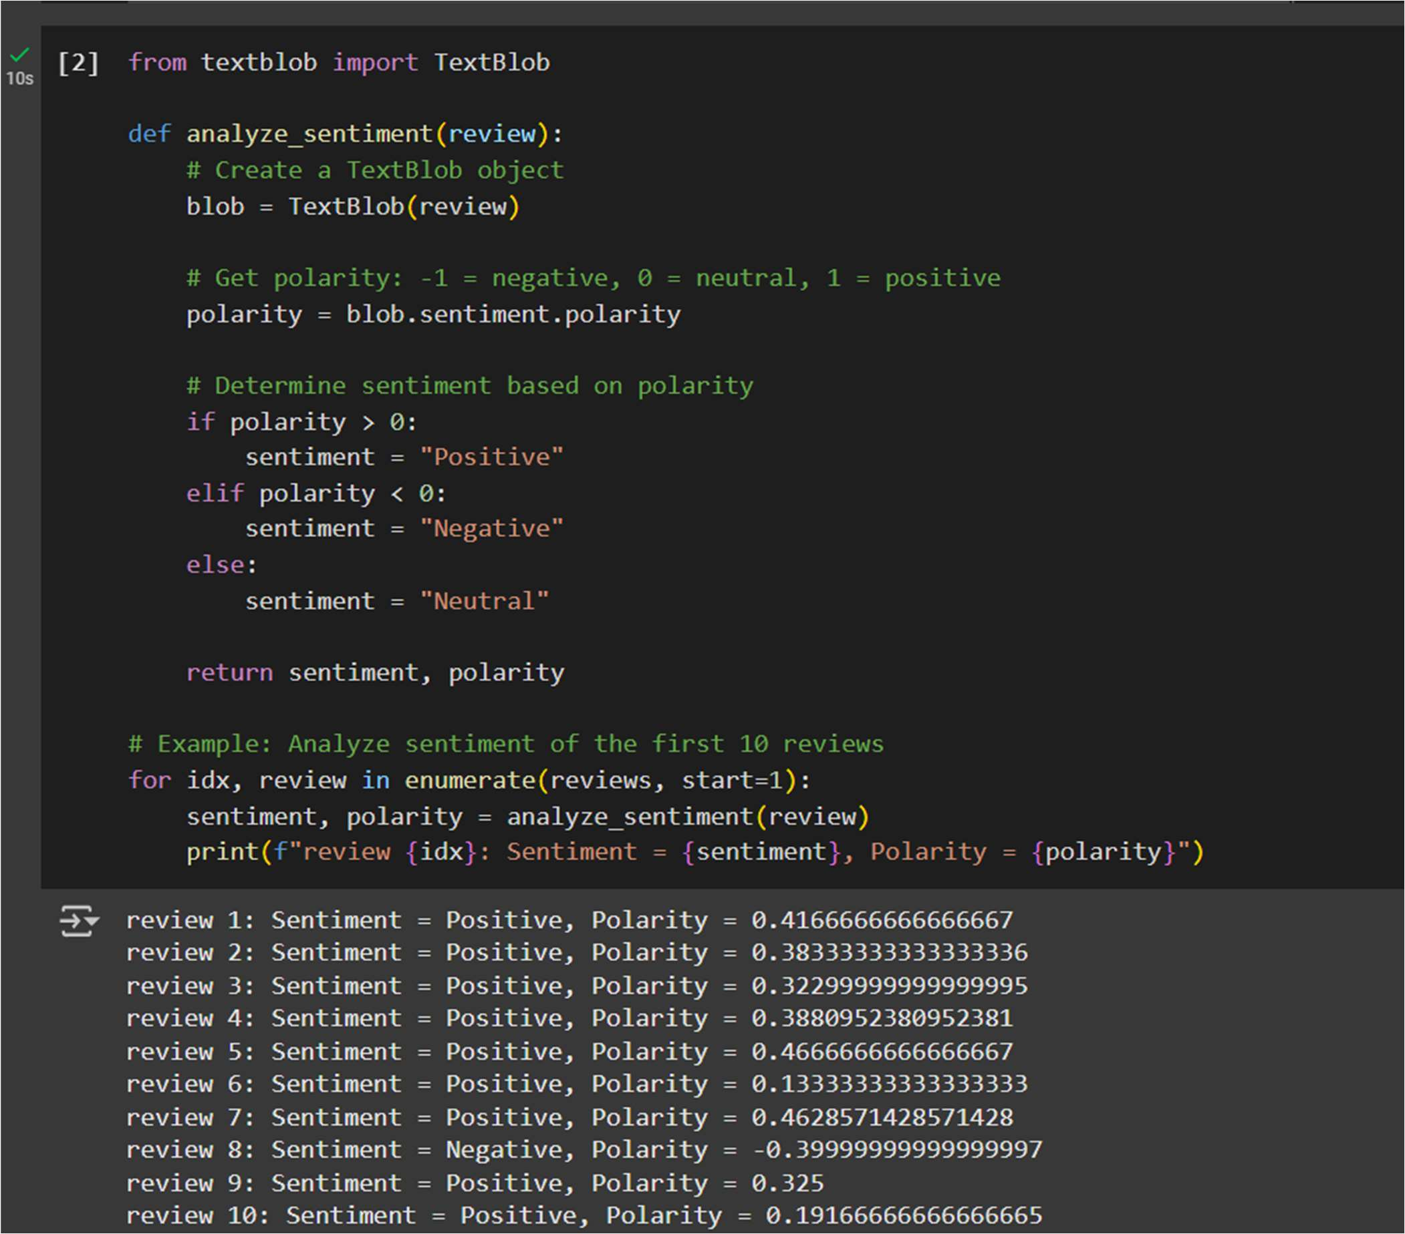

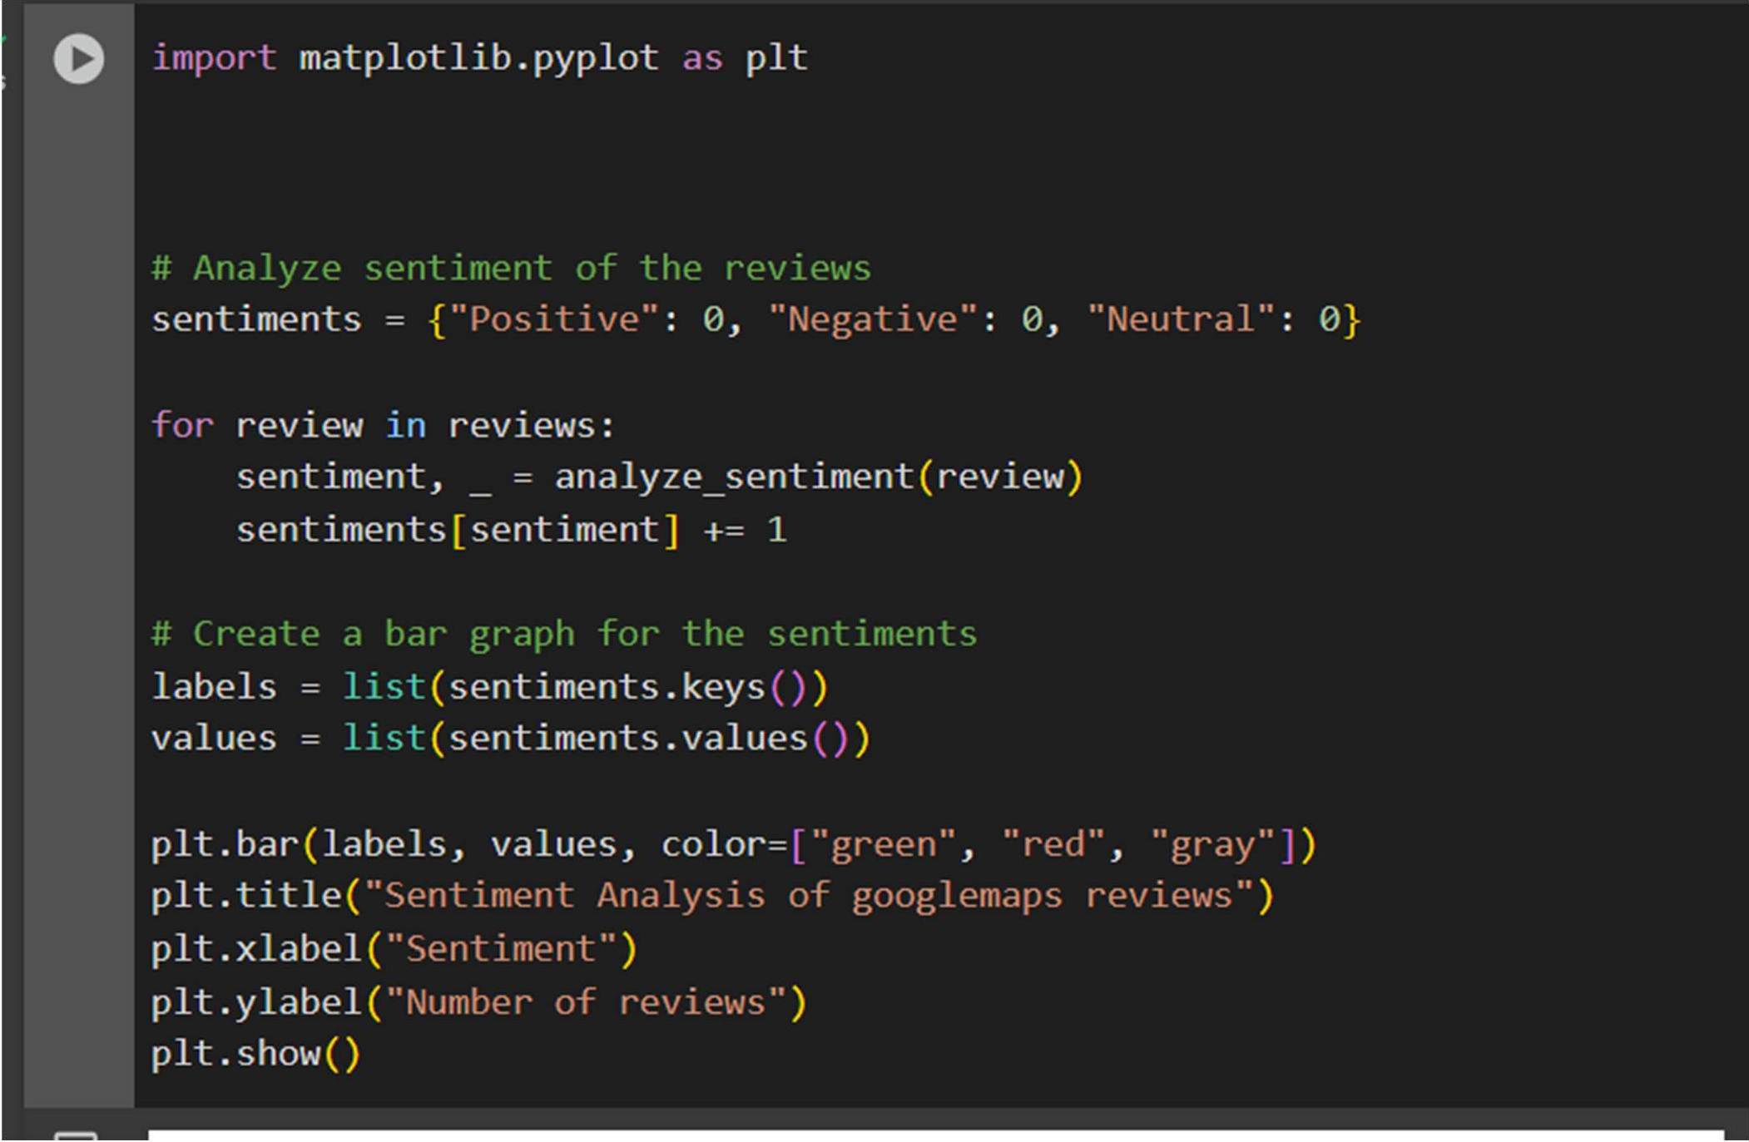

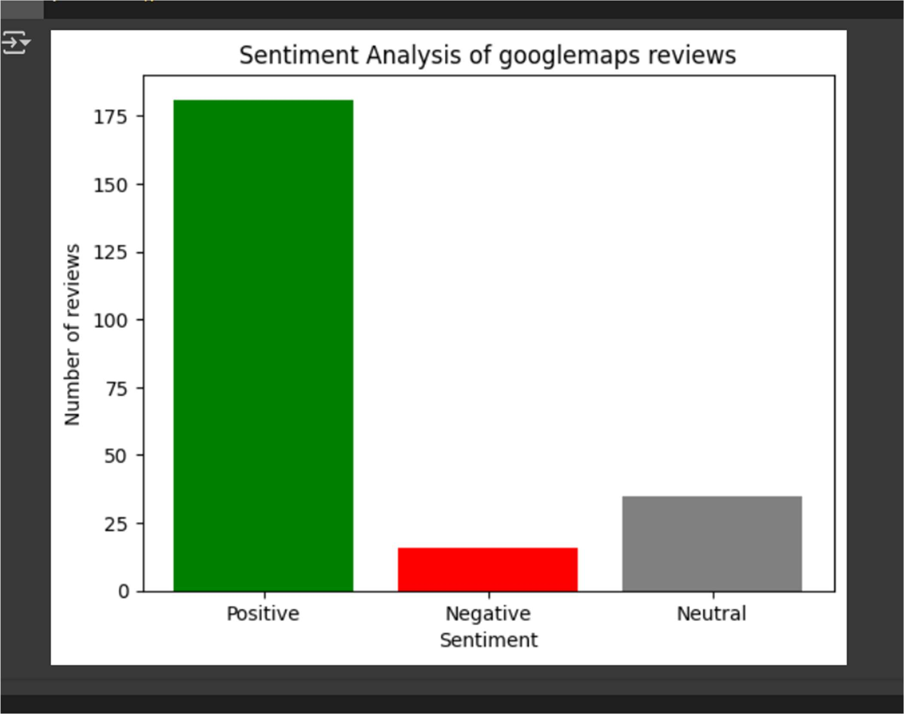

# Insights:

* Most of the people has positive response
* Some have negative response due to bad experience due to technical issues during movie